Summons
In the ______________________________ Justice Court of Utah
__________ Judicial District ________________ County
Court Address ______________________________________________________
_____________________________________  Plaintiff  v.  _____________________________________  Defendant | Small Claims Summons and Affidavit  Online Dispute Resolution Case  _______________________________  Case Number  _______________________________  Judge
To:
Defendant Name and Address
Defendant Name and Address

Scan QR code
to visit page
Notice to the Defendant  A small claims case has been started against you. This court uses online dispute resolution (ODR) to settle small claims cases. You have two options.  Option 1: Using ODR  Instead of going to trial at the courthouse at a specific date and time, you and the plaintiff will work online with a neutral facilitator to reach a settlement. The facilitator will help both parties by asking questions, requesting information, and suggesting clarifications to agreements.    - Within 14 days of receiving this Affidavit, you must register at https://odr.utcourts.gov to try to settle this case.  - If you do not register within 14 days, judgment may be entered against you for the total amount claimed. The plaintiff could garnish your paycheck or take your property to pay the debt.  - Read the Affidavit below. It explains what the plaintiff wants from this lawsuit.  Option 2: Asking to be excused from ODR  You can ask to be excused from using ODR to settle your case by:    - Visiting www.utcourts.gov/small, filling out the Request to be Excused from Online Dispute Resolution, and filing it with the court, or  - calling the court at ___________________________(phone number) to ask for the Request to be Excused from Online Dispute Resolution. Call within 7 days of receiving this Summons.  You might qualify to be excused from using ODR if you:  - need disability-related assistance,  - don’t speak English, or don’t have internet access.  Going to trial  If you can’t come to an agreement with the facilitator’s help, or if you have been excused from ODR, the case will be scheduled for trial. The court will tell you the date, time, and place of your trial.  If you do not go to the trial, you will lose automatically. The court can enter a judgment against you for the total amount claimed by the plaintiff.  If you want to have a jury for your trial, you must file forms to move your case to district court. Visit www.utcourts.gov/small for more information and to find forms.  Finding help    The court’s Finding Legal Help web page (www.utcourts.gov/help) provides information about the ways  you can get legal help, including the Self-Help Center, reduced-fee attorneys, limited legal help and free legal clinics. | Aviso al demandado  Se ha iniciado un caso de reclamos menores en su contra. Este tribunal utiliza la resolución de disputas en línea (ODR, por sus siglas en inglés) para llegar a un acuerdo en casos de reclamos menores. Usted tiene dos opciones.  Opción 1: Usar ODR  En vez de ir a juicio en el tribunal en una fecha y hora específica, usted y el demandante trabajarán en línea con un facilitador neutral para llegar a un acuerdo. El facilitador ayudará a ambas partes haciendo preguntas, solicitando información y sugiriendo aclaraciones a los acuerdos.  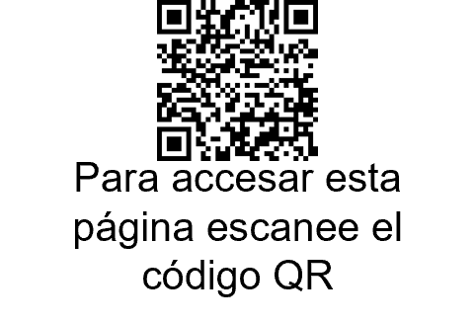  - A más tardar 14 días después de haber recibido esta declaración jurada, usted debe registrarse en https://odr.utcourts.gov para tratar de llegar a un acuerdo en este caso.  - Si usted no se registra dentro de 14 días, se puede dictar un fallo en su contra por el monto total reclamado. El demandante podría embargar su sueldo o tomar sus bienes para pagar la deuda.  - Lea la declaración jurada más abajo. Esta explica lo que el demandante quiere de esta demanda.  Opción 2: Pedir que se le exonere la ODR  Usted puede pedir que se le exonere su participación en la ODR para llegar a un acuerdo en su caso:  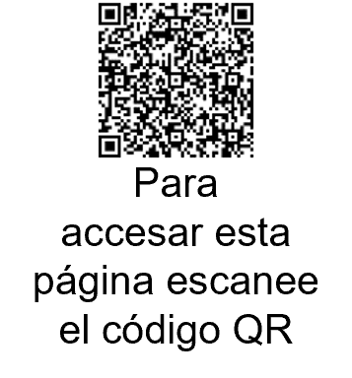  - Yendo a www.utcourts.gov/small, llenando la Solicitud de exención de la resolución de disputas en línea y presentándola ante el tribunal, o  - llamando al tribunal al ___________________________ (número de teléfono) para pedir la Solicitud de exención de la resolución de disputas en línea. Llame dentro de 7 días después de haber recibido este Citatorio.  Usted puede ser elegible para que se le exonere su participación en la ODR si:  - necesita ayuda relacionada con discapacidad,  - no habla inglés o no tiene acceso al Internet.  Para ir a juicio  Si no puede llegar a un acuerdo con la ayuda del facilitador, o si se le ha eximido de la ODR, el caso se programará para juicio. El tribunal le dirá la fecha, la hora y el lugar de su juicio.  Si usted no va al juicio, perderá automáticamente. El juez puede dictar un fallo en su contra por el monto total reclamado por el demandante.  Si desea tener un jurado para su juicio, usted deberá presentar formularios para trasladar su caso al tribunal de distrito. Para más información y para encontrar formularios, visite www.utcourts.gov/small.  Cómo encontrar ayuda  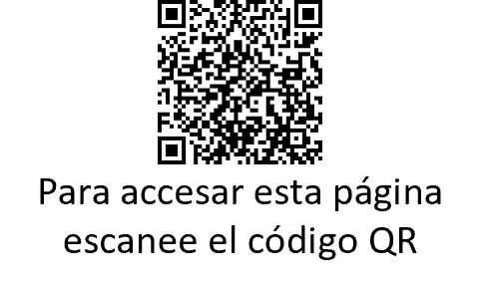  La página de Internet del tribunal, Cómo encontrar ayuda legal, (www.utcourts.gov/help) proporciona información sobre las maneras en que puede obtener ayuda legal, incluido el Centro de ayuda de los tribunales de Utah, abogados con tarifas reducidas, ayuda legal limitada y talleres jurídicos gratuitos.

Date: |  | Signature ►
 |  | Court Clerk

Name
Address
City, State, Zip
Phone
Email
I am [ ] Plaintiff or employee of plaintiff [ ] Plaintiff’s Attorney (Utah Bar #:__________)
In the ______________________________ Justice Court of Utah
__________ Judicial District ________________ County
Court Address ______________________________________________________
_____________________________________  Plaintiff  v.  _____________________________________  Defendant |  | Small Claims Affidavit and Summons  Online Dispute Resolution Case  _______________________________  Case Number  _______________________________  Judge
This form is for small claims cases filed in justice courts using Online Dispute Resolution only. Forms for all other justice courts can be found here: www.utcourts.gov/howto/smallclaims/
1. Defendant owes me the following amounts:
Claim described in paragraph 2.  (Include any prejudgment interest accrued to date and applicable attorney fees. Attach statute or contract authorizing claim for attorney fees.) | $
Plus, the amount I paid to file this claim. | $
Plus, the amount I paid to serve claim. | $
Equals, the total amount I am seeking. | $
plus prejudgment interest, if qualified.
2. The events happened on _________________________ (date). My claim is based on the following facts:
3. Choose one:
[ ] Defendant resides within the jurisdiction of the court.
[ ] The events happened within the jurisdiction of the court..
4. [ ] I am not suing a government entity. I am not suing a government employee for the employee’s on-the-job conduct.
5. [ ] I am not suing on a claim that has been assigned to me.

I declare under criminal penalty under the law of Utah that everything stated in this document is true.
Signed at ______________________________________________________ (city, and state or country).
 |  | Signature ►
Date | Printed Name

